Preparation work for A level Physical Education

Look at the syllabus:
A Level Physical Education Specification (AQA) :
https://www.aqa.org.uk/subjects/physical-education/as-and-a-level/physical-education-7582

Useful resources: (available on Amazon)
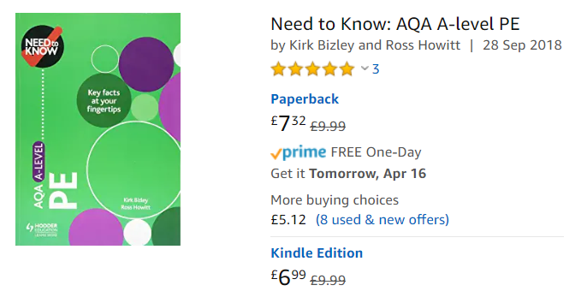
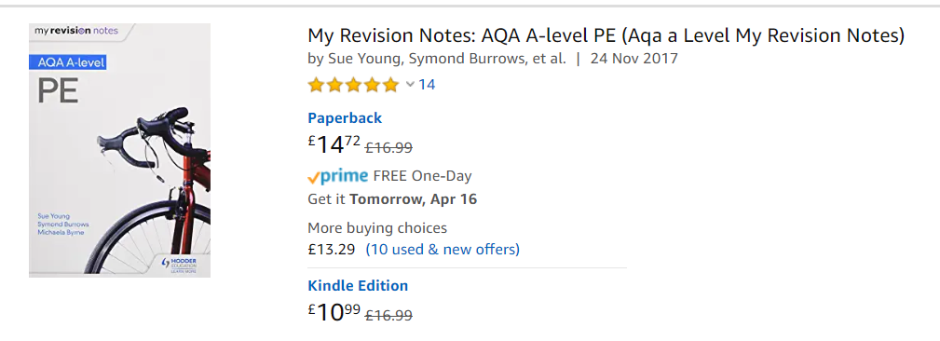

Online tasks / resources:
Anatomy colouring / learning key structures
http://www.supercoloring.com/coloring-pages/human-muscles-back-view-worksheet
Anatomy & Physiology for Dummies (available as a free download)
https://epdf.pub/anatomy-and-physiology-for-dummies.html
Anatomy book
https://yhdp.net/uploads/Essentials-of-Anatomy-and-Physiology.pdf
Quizlet
https://quizlet.com/gb/280837063/aqa-a-level-pe-65-drugs-in-sport-flash-cards/
Documentaries / films:
Activity: Summarise the documentary/film on an A4 page using the 5 Ws: When? Who? Where? What? Why? Use the specification to see how they link to A level PE.

- The English Game - Netflix (for characteristics of football)
- Chariots of Fire – 1981 film (for characteristics of athletics)
- Coach Carter – 2005 film (for psychology - leadership)
- Remember the Titans – 2000 Film (for psychology – group dynmanics)
- Icares – Netflix (drugs in Sport documentary)
- Racism in Football - https://youtu.be/8tEviDXNHzs
- OLYMPIA AND THE OLYMPIC GAMES – DOCUMENTARY (You tube)
Wider Reading
- Sports performers / managers autobiographies
- Any news articles on sport / sport performers / sport funding
- https://www.sportengland.org/ http://www.sportingequals.org.uk/
- http://www.activityalliance.org.uk/
- https://www.womeninsport.org/ https://www.streetgames.org/

