Welcome to A Level Biology. To help you with your studies until you join us here at Callywith See below for some suggestions of books, websites, films, podcasts, TV shows and citizen science activities which will keep you up to date with biological knowledge.
 | 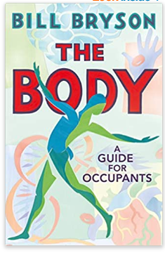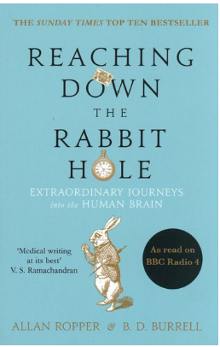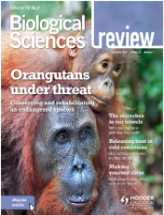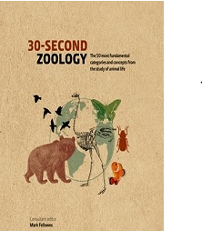
 | 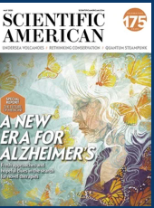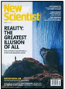
 | 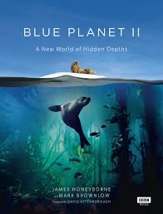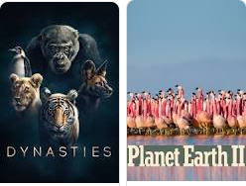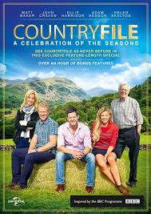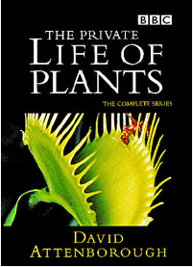
 | Overheard - National Geographic Podcast  Science weekly - The Guardian Podcast  BBC the Documentary Podcast | The Living Planet Podcasts  BBC 30 animals that have made us smarter  BBC Science Hour
 | BBC Science and Nature playlist  Colchester Zoo Live at 11am and 1pm  iPlayer dynasties  iPlayerprimates | Chris Packham live at 9am for social distancing nature talks  iPlayer Seven Worlds One Planet
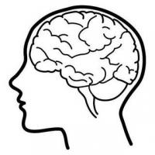 | Citizen Science penguin-watch  Citizen Science rainfall-rescue  The Big Butterfly Count | thebiologist.rsb.org.uk/ gardening-the-planet  thebiologist.rsb.org.uk/-the-wonder-of-whiskers
At A-level you will be following the AQA Specification and will study the following topics:
- Biological molecules
- Cells
- Organisms exchange substances with their environment
- Genetic information, variation and relationships between organisms
- Energy transfers in and between organisms
- Organisms respond to changes in their internal and external environments
- Genetics, populations, evolution and ecosystems
- The control of gene expression
