Chemistry
A Level Chemistry is a fascinating, hands-on and practical subject which is underpinned by key theoretical scientific concepts and required a solid understanding of all GCSE Mathematics content.

BBC Bitesize content is a great starting point: https://www.bbc.co.uk/bitesize/examspecs/z8xtmnb
Choose the exam board you have studied with or AQA which fits really well with A Level OCR Chemistry A. Make sure that you look at the separate Chemistry GCSE content which covers:
Atomic Structure and the Periodic Table
Bonding, Structure and the Properties of Matter
Quantitative Chemistry
Chemical Changes
Energy Changes
The rate and extent of chemical change
Organic Chemistry
Chemical Analysis
Chemistry of the Atmosphere
Using Resources
Practical Skills

There are several CGP books which can really help too. These are available from CGP itself and Amazon as paper copies or Kindle versions are currently FREE.
We recommend the separate Chemistry books with AQA shown below.
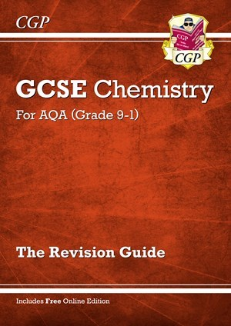
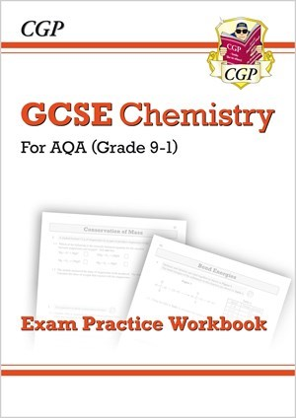
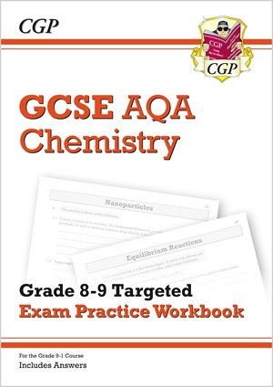
As Maths is so fundamental to Chemistry this is also a great resources:
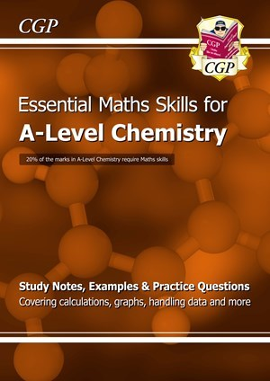
Once you have really consolidated your GCSE work it is time to get a Headstart to Chemistry with this book:
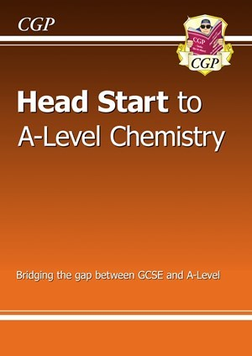

The Khan Academy Website allows you to log on and track your progress through the course you study. It is an American resource but the videos and quizzes for Chemistry are great.
https://www.khanacademy.org
