English Language at A Level
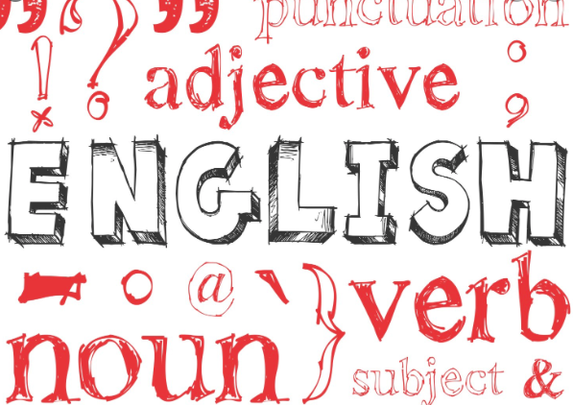
Studying English Language at A Level will be very different to what you will have done at GCSE, however, you will still use similar academic skills such as: analysis, application of linguistic terminology and essay writing. To prepare yourself, there are lots of helpful, interesting and fun things that you can do.

Podcasts:

- Listen to Radio 4’s ‘Word of Mouth’ podcasts available for free to download from the BBC Sounds app (which is also free!) or from the Radio 4 website. Michael Rosen, an English poet and author, hosts the show which features topics related to language such as: Lying (and how to tell when someone is), The First Language, The Language of Comics and even Biscuit Names! https://www.bbc.co.uk/programmes/b006qtnz/episodes/player?page=2

- Listen to a podcast called ‘The Battle for English’ by lexicographer, Susie Dent (from Dictionary Corner on Countdown) https://www.bbc.co.uk/programmes/m000gkv4

YouTube:

- Watch videos about language and linguistics by David Crystal, a writer, lecturer, and broadcaster who has written over 100 books about language including: ‘Rediscover Grammar’, ‘Making Sense of Grammar’ (which are very accessible for A Level students).

Watch Ted Talks about language and linguistics on topics from ‘Why language is humanity's greatest invention’ to ‘ancient language forms’: https://www.ted.com/topics/language

Blogs and websites:

All of these blogs and websites are focused on the English language: its history, its functions and its ever-changing identity. Reading anything that takes your interest is a great place to start:
- https://linguisticus.wordpress.com
- https://grammararium.wordpress.com
- https://aggslanguage.wordpress.com
- https://blog.inkyfool.com/
- http://david-crystal.blogspot.co.uk
- http://www.dictionary.com/

Books:

- David Crystal: Cambridge Encyclopaedia of the English Language/Rediscover Grammar/ Making sense of Grammar. There are a range of excellent texts by David Crystal worth reading. For a full list of his works, visit http://www.davidcrystal.com/
- Bill Bryson: Mother Tongue
- Lynne Truss: Eats, Shoots & Leaves: The Zero Tolerance Approach to Punctuation

TV Shows:

- Watch Stephen Fry’s documentary series ‘Planet Word’: http://www.infocobuild.com/books-and-films/social-science/frys-planet-word-bbc.html
- You will be studying how children acquire language and begin to communicate so watch ‘The Secret Life of 4 / 5 Year Olds’ available for free on All 4.

Newspapers:

- It’s really advisable to start reading a newspaper each day. It’s important that you have an understanding of the world around you - politically, socially, environmentally and technologically - as all of the texts we study are ‘real life’ texts. Try downloading a news app to your phone and a broadsheet newspaper app such as The Guardian.

Revision Guides:

You will be provided with a range of resources and revision materials throughout the course, but Revision Express AS and A2 English Language by Alan Gardiner is a helpful and straightforward revision guide you can order online to support your learning.

Exam Board:

You will be studying on the Edexcel specification for A Level English Language.

