Welcome to Environmental Science. To help you with your studies until you join us here at Callywith See below for some suggestions of books, websites, films, podcasts, TV shows and citizen science activities which will keep you up to date with environmental knowledge, development and hopefully get you excited about what we will be learning in September.
 | 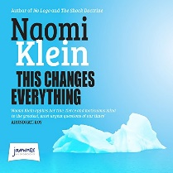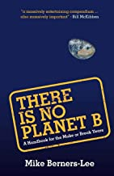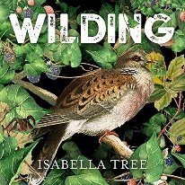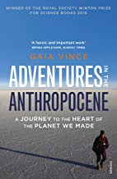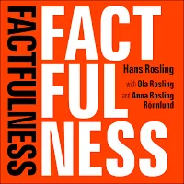
 | 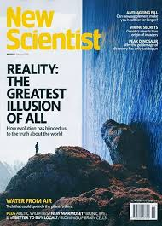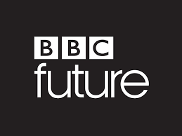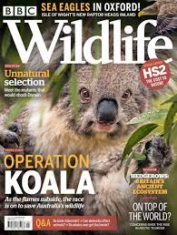
 | 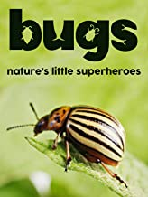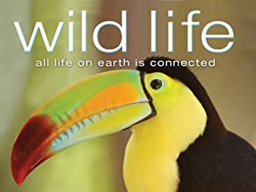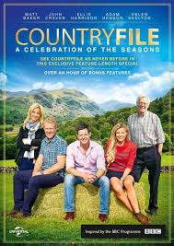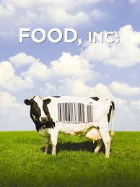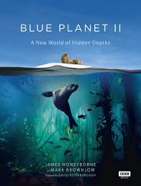
 | Overheard - National Geographic Podcast  Science weekly - The Guardian Podcast  BBC Costing the Earth  BBC the Documentary Podcast | The Living Planet Podcasts  BBC 30 animals that have made us smarter  BBC Science Hour  BBC Putting science to work - Air Pollution
 | BBC Climate forcing  BBC Climate Change  BBC Science and Nature playlist  BBC Sustainable Thinking  Colchester Zoo Live at 11am and 1pm | Chris Packham live at 9am for social distancing nature talks  iPlayer Seven Worlds One Planet  iPlayer dynasties  iPlayer climate-change-the-facts
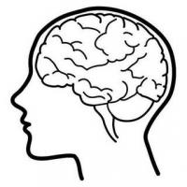 | Citizen Science penguin-watch  Citizen Science rainfall-rescue  The Big Butterfly Count | https://earthchallenge2020.earthday.org/  Transcribing old climate data
At A-level you will be following the AQA Specification and will study the following topics:
- The Living Environment
- The Physical Environment
- Energy and Pollution
- Biological Resources
- Sustainability
- Scientific Methods
The text book can be purchased from the publisher, Amazon or sometimes eBay.
Publisher: Insight & Perspective
ISBN: 9781912190072
