Welcome to Geology. To help you with your studies until you join us here at Callywith See below for some suggestions of books, websites, films, podcasts, TV shows and citizen science activities which will keep you up to date with Earth Science knowledge, development and hopefully get you excited about what we will be learning in September.
 | 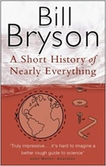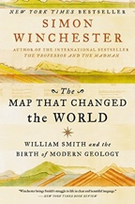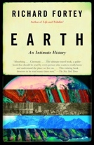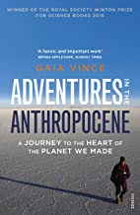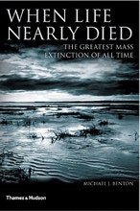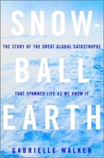
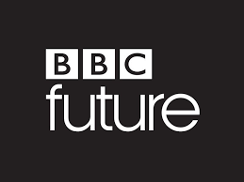
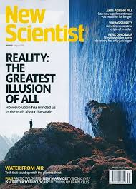
 | 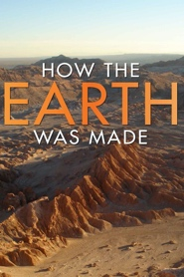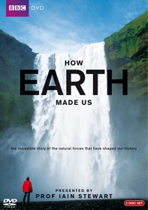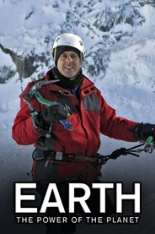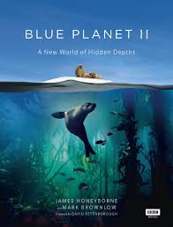
 | Overheard - National Geographic Podcast  Science weekly - The Guardian Podcast  BBC Costing the Earth  BBC the Documentary Podcast | The Living Planet Podcasts  BBC Earth Podcast  BBC Science Hour  BBC Putting science to work - Air Pollution
 | Wave Tank - Coastal Defences  Sand Box - Structural Geology  Plate Tectonics - Making Mountains  Flume Tank - Turbidity Currents  The Day The Mesozoic Died | 10 Things You Didn't know About Earthquakes  10 Things You Didn't Know About Volcanoes  Animal Armageddon Hell On Earth  iPlayer dynasties  iPlayer climate-change-the-facts
 | How Did Atmospheric Oxygen Occur?  Liquid Metal Turns CO2 Into Coal  Turning Carbon Dioxide Into Rock  Oldest Material On Earth Discovered | https://earthchallenge2020.earthday.org/  Plastic Bags And Their Carbon Imprint  Icelandic Volcanism Awakes  Naples Supervolcano Nearing Trigger  Drilling Into The 'Dinosaur' Crater
At A-level you will be following the OCR Specification and will study the following topics:
- Foundations in Geology – Igneous, Metamorphic & Sedimentary Petrology
- Global Tectonics - Plate Tectonics & Earth Structure
- Fossils and Time – Evolution, Mass Extinction & Interpreting the Past
- Economic and Engineering Geology – Mining, Engineering, Oil, Geothermal
- Geohazards and Risk – Volcanology, Earthquakes, Landslides, etc.
- Basin Analysis – Whole Basin Analysis (Welsh & Jurassic)
The text book can be purchased from the publisher, Amazon or sometimes eBay.
Publisher: Insight & Perspective
ISBN: 9781911208143

