Practical: Task 1
As you are hopefully aware there are very little practical based lessons on the A Level PE course as we need to spend the majority of the time completing the theory-based work. However, as I have already mentioned you are assessed in a full competitive event in your main sport.
It would be really good therefore for you to see the sports you can chose from and look at the skills you will need to demonstrate in a competitive situation. Therefore, please complete the first task:

- Log onto the AQA web site and access the A level PE specification.

https://www.aqa.org.uk/subjects/physical-education/as-and-a-level/physical-education-7582

Scroll towards the back of the specification and find the list of practical activities that you can choose from. You will note the list has been updated with some more sports for this year. Hopefully you will find your sport listed here – if your sport is not in the list unfortunately you can’t be assessed in the area eg no gig rowing as not on the list.

- Once you have found your sport please then go to the specific page that highlights the skills you are assessed in – the page should show core and advanced skills and also skills based on attacking, defending and tactical awareness or event one and event two / batting bowling etc. If you can print a copy of the page relevant to you or save it for future reference.

- Using that page please complete a two-sided account of your achievements and success in that sport so far. This is to include:

- Intro – how did you get involved in the sport – how long have you played – you do you / have you played for.
- Any honours you may have achieved – school captain / club success / county or even national level success.
- Add a paragraph on your main strengths within the sport that you play – ideally link this to some of the skills you see on the specification
- Add a paragraph on some of the weaknesses you have in this sport – again link to the skills on the specification.
- Summary – aspirations in the sport – future success – training required etc.

It is also worth pointing out that you will need video evidence of you playing in a full competitive situation – now obviously most summer sports are cancelled at the moment but if any are played towards the end of the summer it is always good to have some early footage.

Anatomy and Physiology
You may find that a lot of the work we cover in Anatomy and physiology you have done already – either in GCSE PE, BTEC Sport or GCSE Biology and Physics. This is true but what we tend to do is look at the basic principles and then apply them to the practical sporting situation.
Therefore, before classes begin in September it would be a really good idea if you could ensure you are aware of the basic elements of the cardio, respiratory and muscle and skeletal systems. This will allow you to move onto the application of these elements much easier.
Therefore, if you can, complete the following six worksheets and keep them as reference points for next academic year.
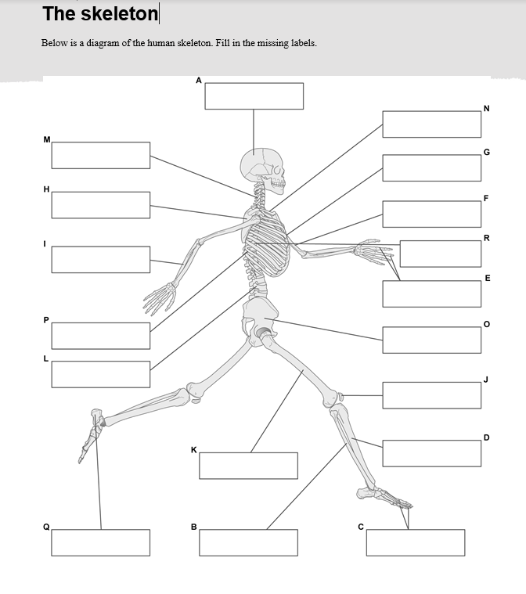
If you can learn all the muscles and bones that would be excellent.
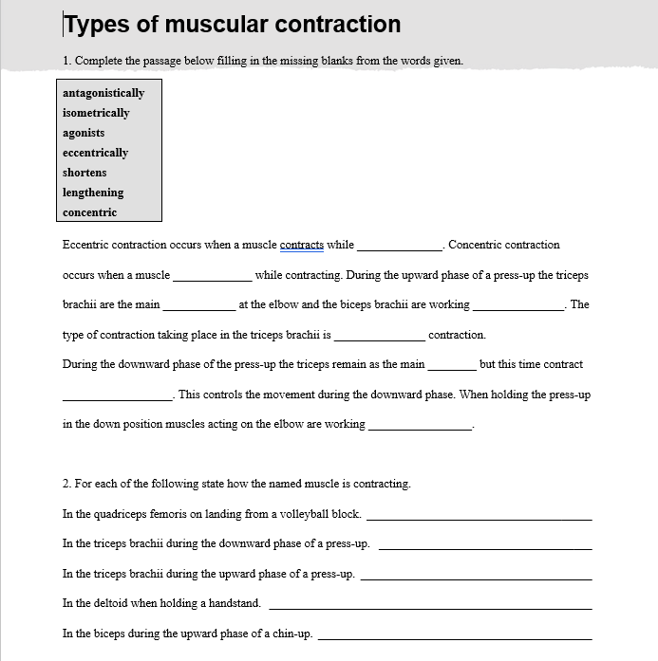
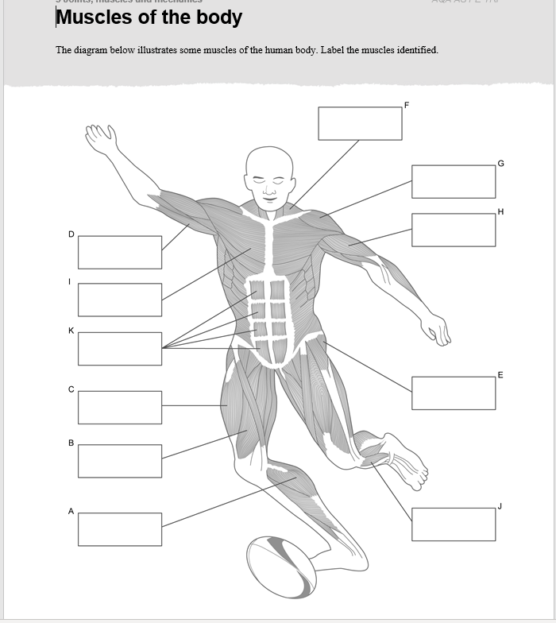

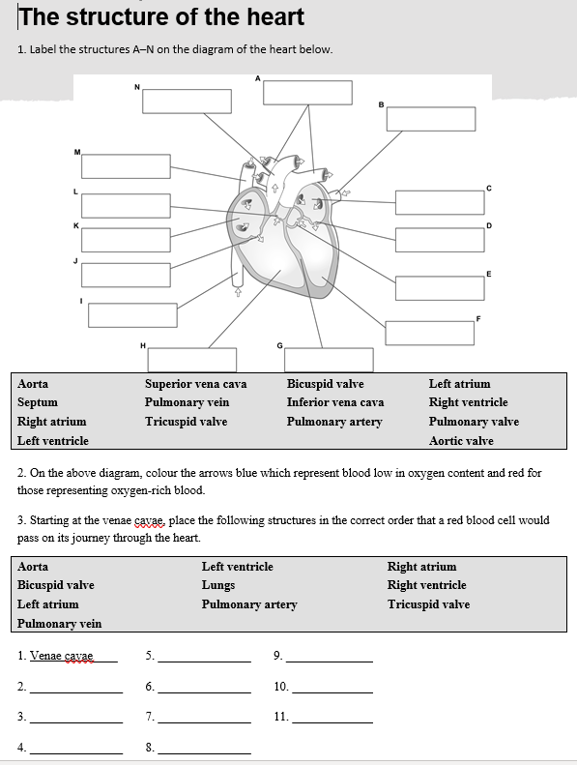

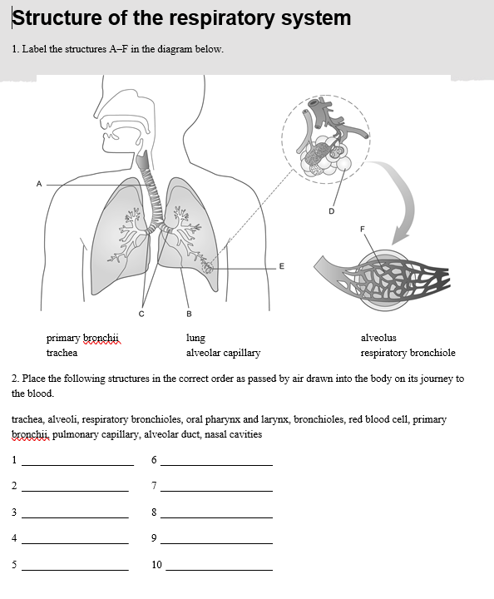

Skill Acquisition 1

Skill acquisition is all about looking at types of skill and being able to analyse them and see how we can learn the skill to the best of our ability. As an athlete who has been coached over many years you would have experienced many different ways in which you learn skills. See if you can produce a mind map that looks at the following methods and types of practice:
- Whole practice
- Progressive part practice
- Whole – part – whole
- Massed practice
- Distributed practice
- Variable practice
- Mental practice

For each one see if you can:
- Add a definition
- Add one advantage
- Add one disadvantage
- Add a practical skill that would be well suited to that particular method and if possible, justify why.

Skill Acquisition 2
In skill and sports psychology we look at a lot of theorists and models and apply them to the practical sporting situation. I appreciate you will not necessarily understand or be able to apply these yet but it would be really good if you could produce two posters that we can add to you file as reference points when we come to teach this area.
Poster 1:
Please complete an A4 poster looking at the who these people are: include basic information if possible – name, date of birth, picture if you can, and brief account of what they are famous for.
- Skinner
- Bandura
- Vygotsky
- Gestalt Theorist
Poster 2:
Please produce a second A4 poster to show the main models that we will look at over the year. Label them with the key words if possible but again do not panic if you do not know what they mean / do.
- Baddeley and Hitch working memory model memory system.
- Whiting’s information processing model
- Psychological refectory period
- Schmidt’s schema theory.

