Drama and Theatre Studies

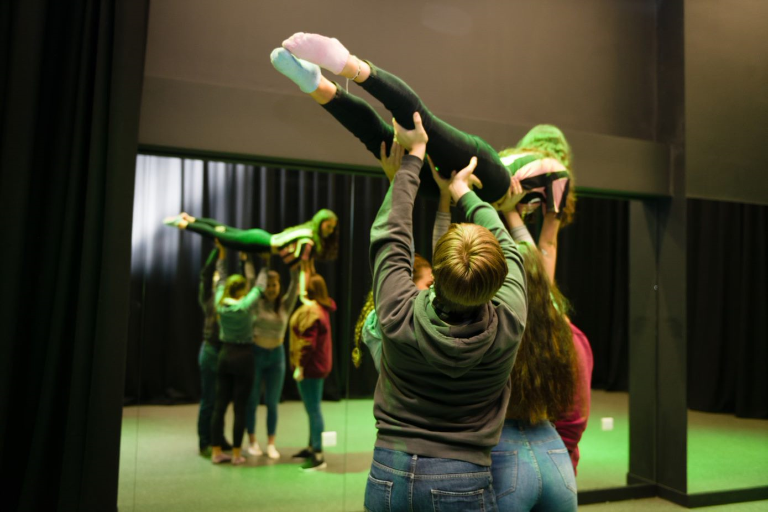

Thank you for showing an interest in the Drama and Theatre Studies A level at Callywith College. We understand that this year has been unsettling for you and wanted to help support you in your transition to attending our wonderful college. The drama department shares ideas, auditions and live screening information via our drama page Callywith Drama on Facebook. There is a video pinned to the top of the page that shows all the fabulous trips and student work we’ve created since opening in 2017. In addition to the Facebook page, we have compiled some information and tasks that can be completed over the Summer holidays before embarking on your journey with us at Callywith.

We highly recommend students access Live theatre screenings which can be found at the following internet locations. Please watch 2 live, full shows and write an evaluation explaining the set, costume and acting, in no more than 500 words. Shows can be accessed here;

http://ntlive.nationaltheatre.org.uk/
https://www.digitaltheatre.com/
https://www.geckotheatre.com/
https://www.franticassembly.co.uk/

Prior Reading List- please read the following key set texts

Lungs, Duncan Macmillan ISBN-13: 978-1849431453
Hedda Gabler, Henrik Ibsen Methuen ISBN 978-0-413-77070-7
Love and Information, Caryl Churchill ISBN 978-1-84842-288-9
The Curious Incident of the Dog in the Night-Time, Mark Haddon, adapted by Simon Stephens Bloomsbury, ISBN: 978-1-4081-7335-0

These scripts can be purchased online as either new or used copies. They may also be available from Libraries once these reopen after isolation ends.

Please email clareunderwood@callywith.ac.uk for a monologue task, the script extract will be provided. Subject Line: Year 11 Monologue Task

