Preparation work for BTEC Sport Level 3

Look at the syllabus:
BTEC Sport Level 3 Extended Diploma in Sport
https://qualifications.pearson.com/content/dam/pdf/BTEC-Nationals/Sport/20161/specification-and-sample-assessments/9781446958278_BTEC_NAT_L3_EXTDIP_SPORT_SPEC.pdf

Useful resources: (available on Amazon)
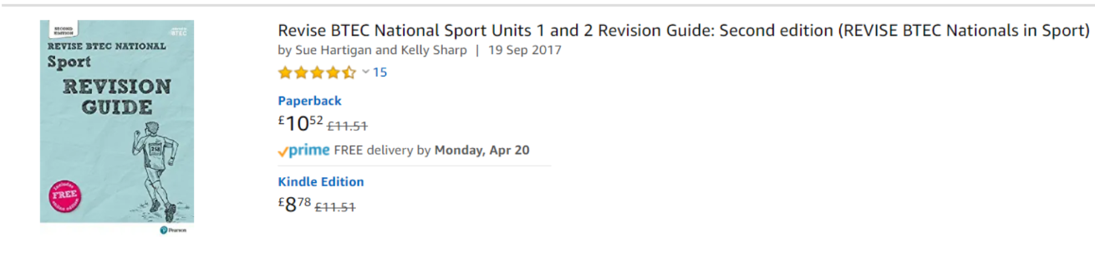

Online tasks / resources:
Top End Sports – Fitness Testing & Training Methodology
https://www.topendsports.com/
Anatomy colouring / learning key structures
http://www.supercoloring.com/coloring-pages/human-muscles-back-view-worksheet
Anatomy & Physiology for Dummies (available as a free download)
https://epdf.pub/anatomy-and-physiology-for-dummies.html
Anatomy book
https://yhdp.net/uploads/Essentials-of-Anatomy-and-Physiology.pdf
Quizlet
https://quizlet.com/gb/280837063/aqa-a-level-pe-65-drugs-in-sport-flash-cards/
NHS Activity Guidelines
https://www.nhs.uk/live-well/exercise/

Documentaries / films:
Activity: Summarise the documentary/film on an A4 page using the 5 Ws: When? Who? Where? What? Why? Use the specification to see how they link to BTEC Sport Level 2.

- Icarus – Netflix (drugs in Sport documentary)
- BBC iplayer: Veganism in Football
https://www.bbc.co.uk/iplayer/episode/p07phy2j/football-going-vegan
- Energy drinks review
https://www.youtube.com/watch?v=S766N-1V1Fo
- Coach Carter – 2005 film (for psychology - leadership)
- Remember the Titans – 2000 Film (for psychology – group dynmanics)
- Racism in Football - https://youtu.be/8tEviDXNHzs
- OLYMPIA AND THE OLYMPIC GAMES – DOCUMENTARY (You tube)

Wider Reading
- Sports performers / managers autobiographies

Anatomy and Physiology
You may find that a lot of the work we cover in Anatomy and physiology you have done already – either in GCSE PE, BTEC Sport or GCSE Biology and Physics. But this is the first exam unit which you will take in January, so it is important you do not forget anything!
Therefore, before classes begin in September it would be a really good idea if you could ensure you are aware of the basic elements of the cardio, respiratory and muscle and skeletal systems. This will allow you to move onto the application of these elements much easier.
Therefore, if you can, complete the following six worksheets and keep them as reference points for next academic year.
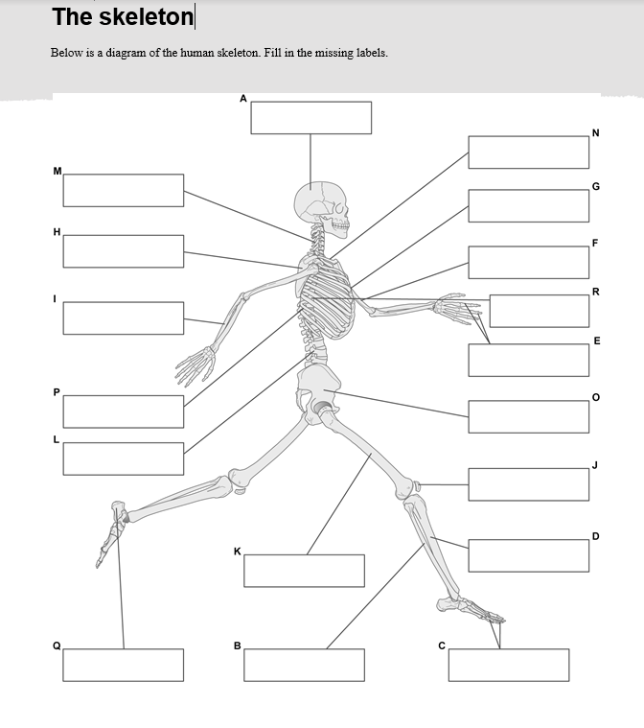
If you can learn all the muscles and bones that would be excellent.
