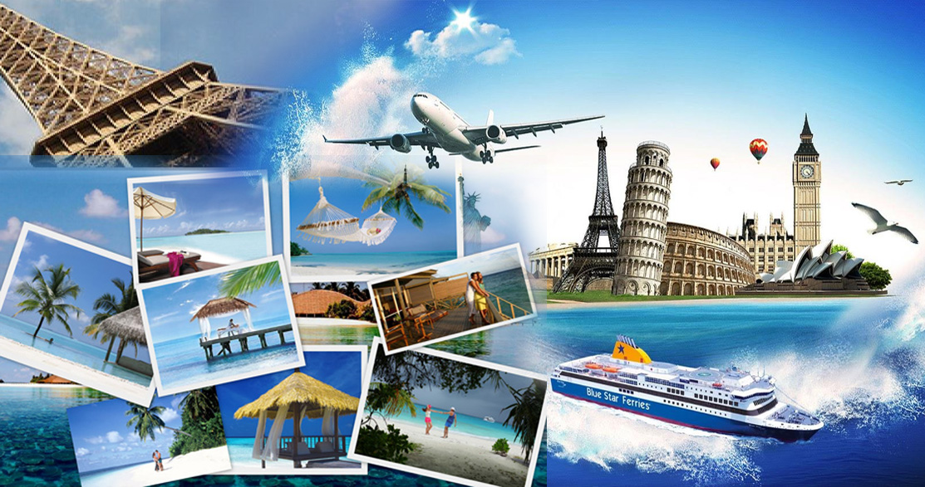
Travel & Tourism at Callywith College

Hello and welcome to Travel & Tourism at Callywith College! We Look forward to seeing you in September, but before then we thought that you might like to have a look at some of the things you will be doing in Travel & Tourism when you get to college.

We look forward to seeing you soon,
Huw & Helen - The Callywith T&T team

Trips:
How can you run a Travel and Tourism course without trips? We offer a wide variety of trips that are linked to the content you will learn. These include:
Exploring Cities and UK Culture
Exploring local tourism organisations
Investigating Newquay Airport
Investigating Visitor attractions
As a taster, have a look at:- https://youtu.be/aKvDxXranls

Links to Employers:
Tui – the UK’s largest tour operator
The Eden Project
Newquay Airport
Sur’s Up – Surf school

What will you be studying?...

The World of Travel & Tourism:
You will be introduced to different types of travel and tourism and the diverse organisations that make up the industry. You will examine its scale, explore new innovations and consider the external factors that challenge its operations.
www.wttc.com – World Travel and Tourism Council – works to raise awareness of travel and tourism as one of the world’s largest sectors and is a great source of facts and figures
www.travelmole.com – Travelmole – produces articles that can contribute to the understanding of many aspects of the Unit looking at the different components that make up the Travel & Tourism Industry

Global Destinations:
This unit will develop your awareness of the traveller’s world by knowing locations and differentiating between the appeal of global destinations while understanding the many factors and trends that influence their popularity.
www.worldtravelguide.net – World Travel Guide – useful for information and videos on the appeal of destinations
www.lonelyplanet.com – Lonely Planet – guides providing information and videos on the appeal of destinations

Visitor Attractions:
Here you will learn about the range of places and attractions Tourists visit around the world. You develop an understanding of how these attractions try to appeal to a range of different tourists and how they deal with competition. Have a look at some of these links to find out more...
Top places to travel around the world: https://www.youtube.com/watch?v=yiG6aIU9TYM
https://www.skyscanner.com/tips-and-inspiration/inspiration/9-of-the-most-visited-tourist-attractions-in-the-world
Budget destinations: https://www.youtube.com/watch?v=sRyslbdtT90
Advertising attractions
https://www.youtube.com/watch?v=K5ZqZKPnfE4
Using websites and social media:
https://www.altontowers.com
Number of visitors to UK attractions
https://www.visitbritain.org/annual-survey-visits-visitor-attractions-latest-results

Managing Customer Service Expectations in Travel & Tourism:
Effective management of the customer experience is becoming increasingly important to the success of a Travel & Tourism Organisation. The knowledge and understanding gained in studying this unit will be invaluable to you when seeking employment within the industry
‘Heathrow: Britain's Busiest Airport (ITV)’ – a range of videos highlighting what happens in a busy airport
www.merlinentertainments.biz – Merlin Entertainments – search for ‘Merlin Entertainments annual report’ – useful for research, monitoring and analysis of customer service

Passenger Transport:
In this Unit you are required to examine the changes in approach to passenger transport and understand how smart technologies have influenced the accessibility of passenger transport options for passengers.
www.20thcenturylondon.org.uk – Exploring 20th Century London – search for ‘information on car ownership’
https://www.gov.uk/government/collections/transport-statistics-great-britain – GOV.UK – Transport Statistics in Great Britain

Sustainable Tourism:
Build your understanding how tourism impacts on the world its people, the money made and the environment. Watch and read to find out more..
What are the negative impacts of tourism? -https://www.youtube.com/watch?v=Vyt1HdR4uLw
https://www.youtube.com/watch?v=fQjEHj34W88
What is sustainability? - https://www.activesustainability.com/sustainable-development/what-is-sustainability/
How can we be more sustainable in Travel & Tourism? - https://www.youtube.com/watch?v=JFbbKbdqoJg

Additional Websites & Resources:
TTG Media - https://www.ttgmedia.com/news - Travel Industry News
Travel Bulletin - http://www.travelbulletin.co.uk/ - A website for all those that work in the industry
Travel Daily Media - https://www.traveldailymedia.com/uk/ - Travel News
ABTA - https://www.abta.com/industry-zone/reports-and-publications/abta-travel-trends-reports - Travel Trends Report

TV Programmes and Documentaries:
The Travel Show - https://www.bbc.co.uk/programmes/n13xtmtp
Race Against the World - https://www.bbc.co.uk/programmes/m0002tvs
Holidays Unpacked - https://www.channel4.com/programmes/holidays-unpacked
A Very British Airline - https://www.bbc.co.uk/programmes/p01yyh99 - behind the scenes at BA
Simon Reeve Around the World - https://www.bbc.co.uk/programmes/articles/hvfqhq3kbx6pYw4Sv4NQLd/simon-reeve-around-the-world

Preparation Activities:
- Read the recent ABTA Travel Trends and create a fact sheet about the top 5 travel destinations which includes the main features and attractions, what is the appeal of the destination and their key gateways (airports/sea ports/rail access).

- Ideal holiday (no limits) - Research and put together a travel itinerary for your ideal holiday

- Choose a local tourist area. e.g. Padstow, Newquay. Create a factsheet to include its main features & facilities, local transport facilities, what tourists does it most appeal to and what do you think could improve it for tourists.

