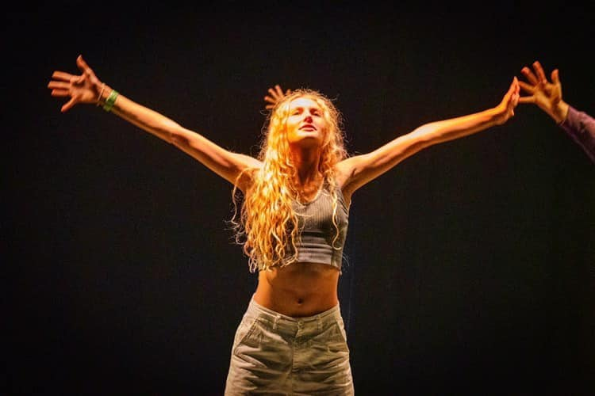

Performing and Production Arts

Thank you for showing an interest in the Full time Performing and Production Arts at Callywith College. The drama department shares ideas, auditions and live screening information via our drama page Callywith Drama on Facebook and our Instagram account. There is a video pinned to the top of the page that shows all the fabulous trips and student work we have created since opening in 2017. In addition to the Facebook page, we have compiled some information and tasks that can be completed over the summer holidays before embarking on your journey with us at Callywith.

We suggest seeing as much live theatre as possible. If you are unable to visit the theatre, we highly recommend students access Live theatre screenings, which can be found at the following internet locations. Please watch 2 full shows and write an evaluation explaining the set, costume and acting, in no more than 500 words. Shows can be accessed here;

http://ntlive.nationaltheatre.org.uk/
https://www.digitaltheatre.com/
https://www.geckotheatre.com/
https://www.franticassembly.co.uk/

Please read a full play script of your choice and write a 500 word evaluation about characterisation and how you would stage the play. You can borrow scripts from most public libraries.

Please email clareunderwood@callywith.ac.uk for additional support or questions about any of our wonderful courses. We are looking forward to welcoming you in person. Have a wonderful summer, stay safe and see you soon!

