A Guide to using to Unifrog to find out more about Post-18 Options

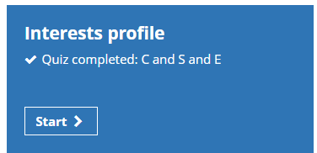
Complete the quiz. Reflect on how accurate you think the profile is? You can search the Careers and Subject Libraries to identify matching jobs using one, two or three of your higher scoring criteria. Have a go and watch the film and open the profile of the jobs that interest you. Download your profile by clicking on ‘Push to Locker’.

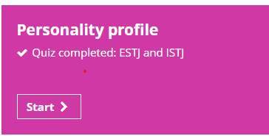
Complete the quiz. How accurate do you think the ‘personality type’ is? Look at your scores in terms of the following four scales:
*Interacting with people * Interacting with the world
* Making decisions *Making plans
Do you think your scores are accurate? ‘Push to Locker’.

Complete searches by ‘keyword’ (job title) and by college subjects. Watch the film and look at the profile for several of the ‘Close matches’. If you like a profile ‘Save it to favourites. You may also want to have a look at the next group of job profiles that were ‘Medium matches.

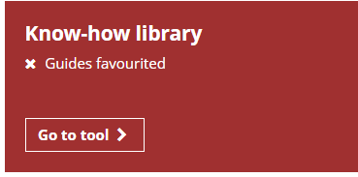
You can find guides about just about anything! Search by a keyword. Have a look at guides that appear interesting. Have a look at some of the ‘trending’ guides

A Massive open online course or MOOC is “an online course aimed at unlimited participations and open access via the web”. Use the search option to find MOOCs of interest to you or go down the alphabetical list and pick out any that appear interesting. Add five MOOCs to create a shortlist. ‘Save courses.’
Have a look at the many ‘Upcoming webinars.’ Are any of interest to you? You will be able to access them by logging onto Unifrog at the stated time. There are also lots of recorded webinars, some may well be of interest/use to you. For example, there is one on ‘Personal Statement Writing’ which may help you tomorrow.

This gives you access to lots of films, podcasts, books……. that are relevant to the subject you are thinking of studying. Search by a key word or your
college subjects
Enter up to ten in or out of college activities, such as a part-time job, sport, music, drama, voluntary work……………

.

Add examples of how you have developed the twelve different competencies.

Read the first page. There is a search facility to help you find an apprenticeship in your area by picking some standards that interest you and then inputting your postcode. This is similar to the Government’s ‘Find an Apprenticeship tool.’

This lets you know about a range of opportunities that you may benefit from. These include: scholarships, summer schools, residentials, gap year activities and virtual work experience.

You may want to look at some of the other options available, such as Oxbridge or information on universities in different countries or continents. Look at any you are interested in.

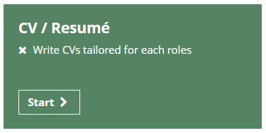
You are likely to have a CV that probably needs updating. Unifrog is a great tool for producing a high-quality well-presented CV. Fill in the information required by each section. Don’t worry if you do not finish, you can do this later (in fact you can keep updating and improving it). ‘Push it to locker.’

A Guide to using to Unifrog to find out more about Higher Education Options

This is an excellent tool for identifying courses you might like to study at university. Search either by entering a key word or/and by entering your current course or courses. Start by clicking on ‘close match’ to look at courses that closely match your keyword and/or your currents course(s).

Each guide has several really helpful sections: starting with a summary of the film, then an ‘In a nutshell’ summary, then ‘getting in’ ………………………….. Work your way down these.

Look at all the guides that appear interesting and consider looking at ‘people also liked’ suggested courses. Each time watch the film and open and read the guide.

You may have three or four close match courses that you think are interesting. After looking at the ‘close matches’ you could have a quick look at the list of ‘medium matches’ in case any of those catch your eye and are worth considering.
Read the first page. On the third page enter the ‘best grades you are likely to get by the time you leave school/college’. Enter a subject you are interested in studying. Then click on any of the ‘subjects you might like’ that interest you.

Use the ‘filters’ to narrow your search. You may want to be in a particular region or would like a sandwich course (one with a placement year) or ……………….. Then use the ‘rank’ feature to help you identify the most attractive university for the course you are interested in. The Education Guardian publishes University Subject League Tables based on criteria, such as student feedback and graduate job opportunities……………. Click on that and it will let you know how highly different university courses are ranked. There are other university league tables, such as those compiled by the Complete University Guide

Click on 5 courses and save them. Read more about each one. You do not have to stick to these five. You can go back and search and select again (as many times as you want!)

